佣金协议
COMMISSION AGREEMENT
甲方FIRST PARTY
EVANGEL INTERNATIONAL MACHINERY LIMITED
乙方SECOND PARTY
Mr Spencer
With reference to the contract No. EV2025J0086F date Oct 14th 2025, the first party has agreed and confirmed to pay (USD 1,000) which is regarded as commission for their service on this deal under the total contract valve USD16,300 Payment of the said commission shall be made before Nov 30th, 2025.
有关于2025年10月14日签订的合同EV2025J0086F,甲方同意并确认付予USD 1,000 (大写美金壹仟元整)以作为其为该合同付出努力的佣金。该款项为合同总金额USD16,300的佣金。甲方在合同应在2025年11月30号前将佣金款项电汇至乙方账户。
乙方收款账户：
Acct number: 1015462300
Beneficiary Name: CHI-SPEN MULTI CONCEPT NIG LIMITED
Bank Name: Zenith bank PLC
SWIFT: ZEIBNGLA
本合同双方签字盖章即为有效。(This contract is valid upon signature and seal by both parties (fingerprints are also acceptable).)

For First Party For Second Party,
---------------------------- ----------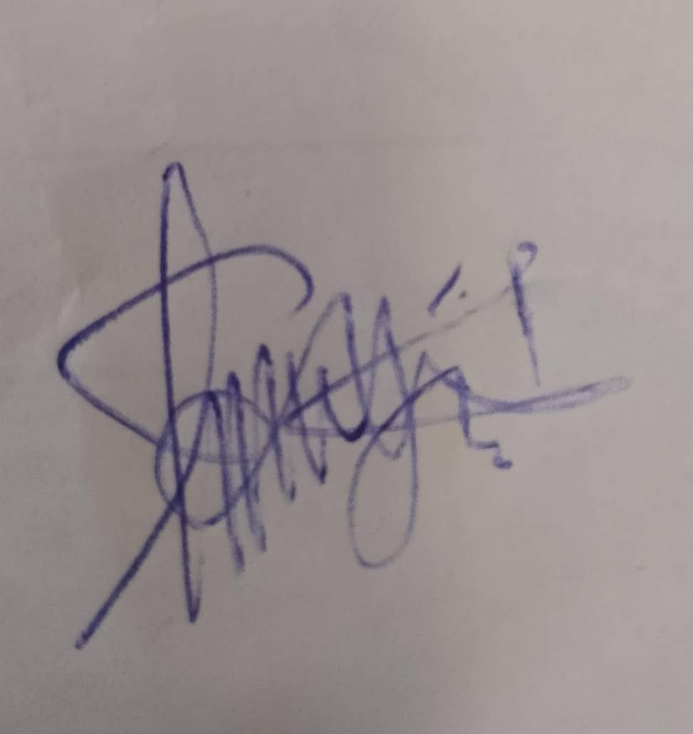-----
Authorized Signature Authorized Signature, Mr spencer For CHI-SPEN MULTI CONCEPT NIG LIMITED.

